Russian weekly grain, September 2-3, 2025
IKAR
Not for reproduction and redistribution. It is our policy that RWG and its parts are NOT distributed and NOT meant to ANY government body or agency. Thank you for your understanding and cooperation

As usual for the beginning of next month, this report contains both weekly and monthly wrap-ups…
***
Graph of the week: our harvest yields graph analyzer (in bunker weight!)

It seems after 15% of area harvested, wheat yields in Siberia рave gained a foohold on record high levels,`and then we will see. Part of it may be associated with “wet harvesting”: farmers take any opportunity to get into fields.

Hot topics and headlines

Final August wheat export figure turns out to be much higher than we expected: 4.4 mmt. It’s mostly due to three factors: (1) very high Black Sea terminals shipments, (2) unexpectedly high direct railroad shipments to S.Caucasus, and Middle Asia markets, (3) quite modest terminals workload with alternative grains – corn and barley… And despite Azov Sea logistical problems…

Our view on September volumes is approximately the same as for August: 4.2-4.4 mmt...
***
Among other things, IKAR elevates its forecast for 2025 pulses output. Very roughly and preliminary, we see an enormous record high crop for peas (5.3 mmt), chick peas (880 tmt), lentils (720), or 6900 tmt in clean and dry equivalent. But to be on a safe side, our official forecast is 6500 tmt: weather still may affect the crops size… Having said so, one should note that quality of both crops is seen as questionable, especially of lentils…
***
Seasonal grains price decline continues. Our key FOB Black Sea 12.5% wheat price index is seen now as $228 per ton, and below it, 11.5% is at $226 per ton, and below it.
***
In previous years during the harrvest period Urals and Siberia farmers tended to wait until grains become more or less dry after rains. This year they made right conclusion from 2024 disaster and don’t miss any chance for harvesting, irrelevant of the grains moisture level…
***

Hot topic 1. Export pace

Rus grains export accrdng to ports and railway shipments data, tmt (subject to further revisions)
 | Wheat |  |  |  |  | Barley |  |  |  |  | Corn |  |  |  |  | All grains + pulses
 | 2023/24 | 2024/25 | 2025/26 |  |  | 2023/24 | 2024/25 | 2025/26 |  |  | 2023/24 | 2024/25 | 2025/26 |  |  | 2023/24 | 2024/25 | 2025/26
 |  |  | Ports | In-land | Total |  |  | Ports | In-land | Total |  |  | Ports | In-land | Total |  |  | Ports | In-land | Total
July* | 4133 | 3425 | 1620 | 117 | 1737 | 1201 | 935 | 528 | 41 | 569 | 547 | 345 | 531 | 5 | 536 | 6166 | 4890 | 2719 | 202 | 2921
August | 5367 | 5490 | 4011 | 363 | 4374 | 1177 | 820 | 476 | 61 | 537 | 276 | 310 | 247 | 2 | 250 | 7162 | 6785 | 4871 | 465 | 5336
September 1-2 | 5345 | 5840 | 206 | 0 | 206 | 999 | 745 | 0 | 0 | 0 | 281 | 300 | 0 | 0 | 0 | 7508 | 7182 | 206 | 0 | 206
October | 5049 | 5590 | 0 | 0 | 0 | 545 | 655 | 0 | 0 | 0 | 595 | 300 | 0 | 0 | 0 | 6729 | 7028 | 0 | 0 | 0
November | 3397 | 5585 | 0 | 0 | 0 | 395 | 320 | 0 | 0 | 0 | 640 | 450 | 0 | 0 | 0 | 4792 | 6562 | 0 | 0 | 0
December | 3865 | 3185 | 0 | 0 | 0 | 363 | 475 | 0 | 0 | 0 | 591 | 430 | 0 | 0 | 0 | 5282 | 4408 | 0 | 0 | 0
January | 3938 | 3470 | 0 | 0 | 0 | 434 | 350 | 0 | 0 | 0 | 835 | 420 | 0 | 0 | 0 | 5590 | 4605 | 0 | 0 | 0
February | 4251 | 2410 | 0 | 0 | 0 | 456 | 295 | 0 | 0 | 0 | 843 | 235 | 0 | 0 | 0 | 5894 | 3184 | 0 | 0 | 0
March | 4646 | 2330 | 0 | 0 | 0 | 450 | 90 | 0 | 0 | 0 | 790 | 70 | 0 | 0 | 0 | 6304 | 2795 | 0 | 0 | 0
April | 4929 | 2250 | 0 | 0 | 0 | 977 | 25 | 0 | 0 | 0 | 651 | 70 | 0 | 0 | 0 | 6907 | 2588 | 0 | 0 | 0
May | 4660 | 2360 | 0 | 0 | 0 | 724 | 35 | 0 | 0 | 0 | 615 | 100 | 0 | 0 | 0 | 6343 | 2694 | 0 | 0 | 0
June | 4580 | 1430 | 0 | 0 | 0 | 591 | 30 | 0 | 0 | 0 | 514 | 90 | 0 | 0 | 0 | 5889 | 1717 | 0 | 0 | 0
Total | 54161 | 43365 | 5838 | 480 | 6317 | 8312 | 4775 | 1004 | 102 | 1106 | 7178 | 3120 | 779 | 7 | 786 | 74566 | 54437 | 7796 | 666 | 8462
September 1-2 | 393 | 517 | 206 | 0 | 206 | 100 | 66 | 0 | 0 | 0 | 17 | 11 | 0 | 0 | 0 | 522 | 604 | 206 | 0 | 206
01.07-02.09 | 9893 | 9432 | 5838 | 480 | 6317 | 2478 | 1821 | 1004 | 102 | 1106 | 841 | 666 | 779 | 7 | 786 | 13850 | 12279 | 7796 | 666 | 8462

Hot topic 2. September 1-2 countries export rating, subject to further revisions
All grains | 206 |  | Wheat | 206 |  | Barley | 0 |  | Corn | 0
BANGLADESH | 53 |  | BANGLADESH | 53 |  |  | 0 |  |  | 0
EGYPT | 50 |  | EGYPT | 50
NIGERIA | 47 |  | NIGERIA | 47
ISRAEL | 41 |  | ISRAEL | 41
N/A | 13 |  | N/A | 13
TURKIYE | 4 |  | TURKIYE | 4

Hot topic 3. Ruble exchange rate is down to both hard currencies

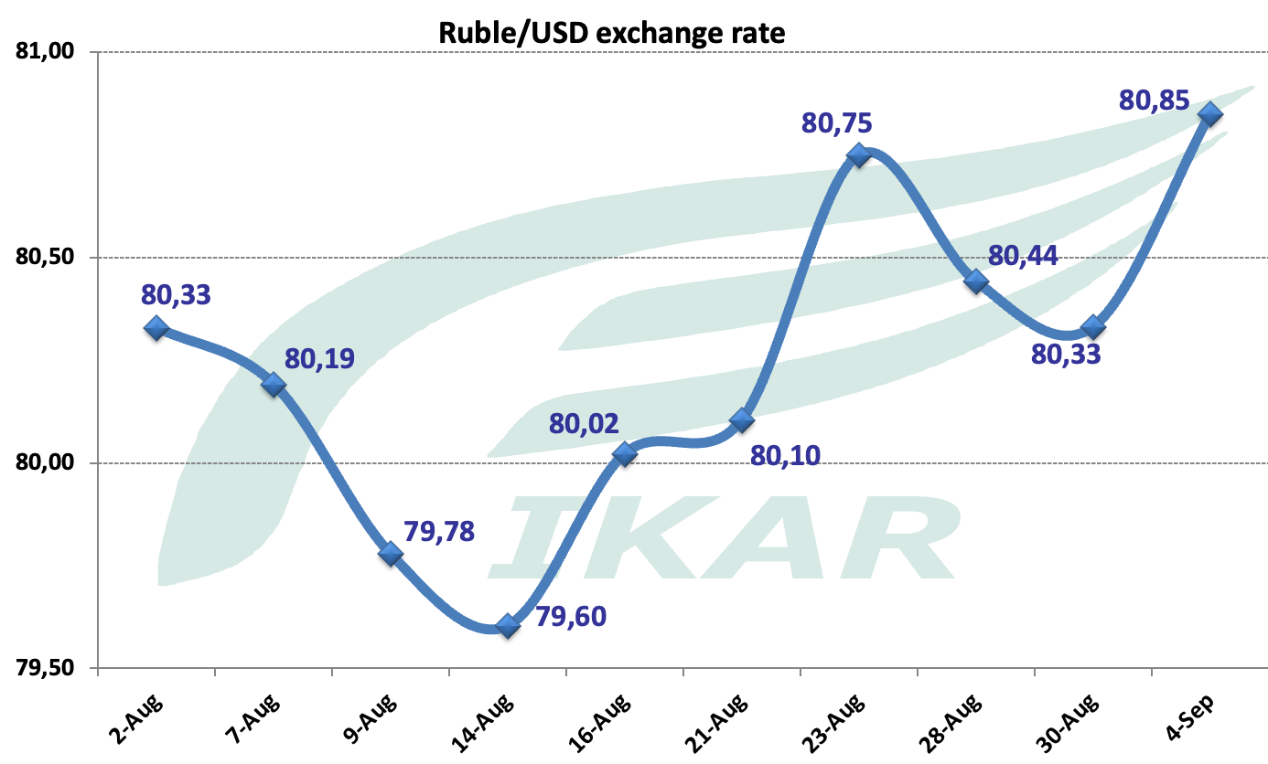

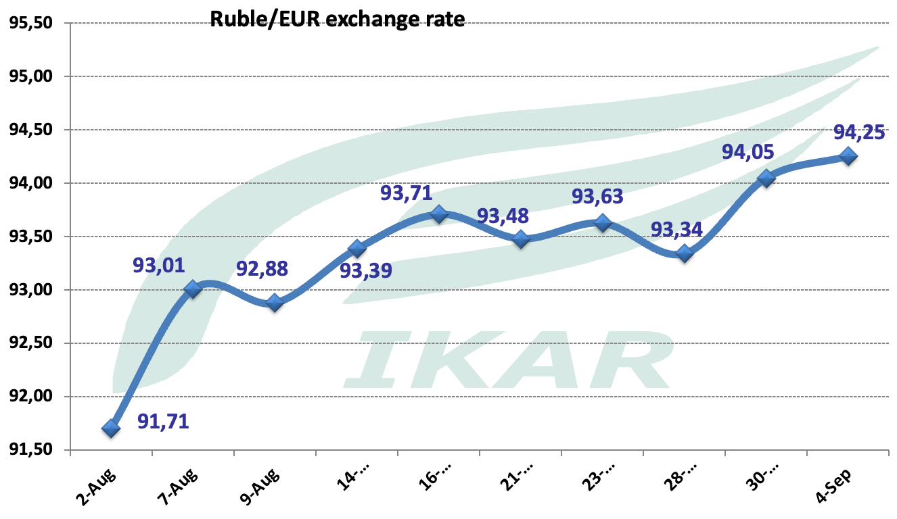

Hot topic 4. All export prices are down.
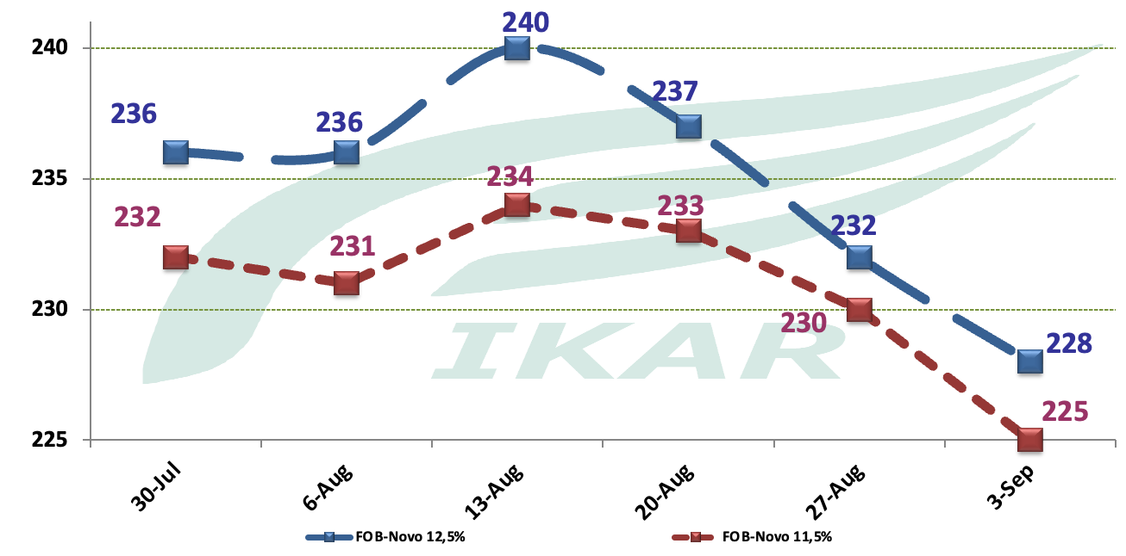

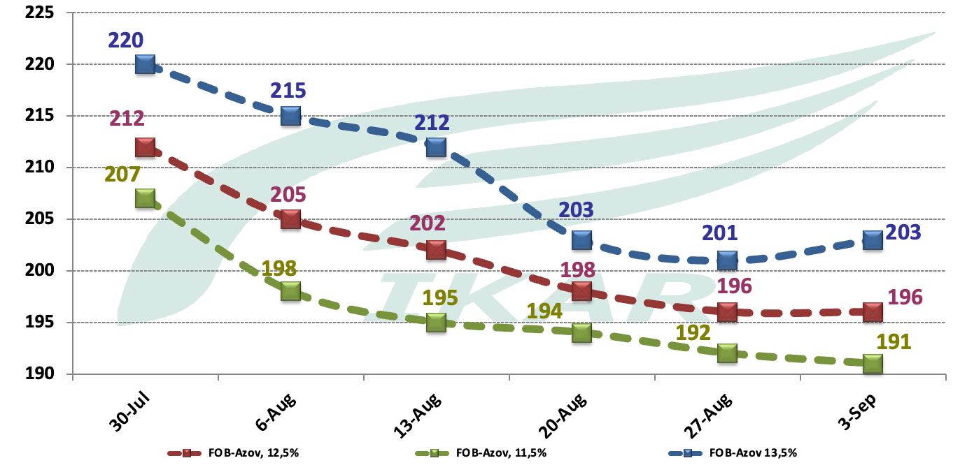

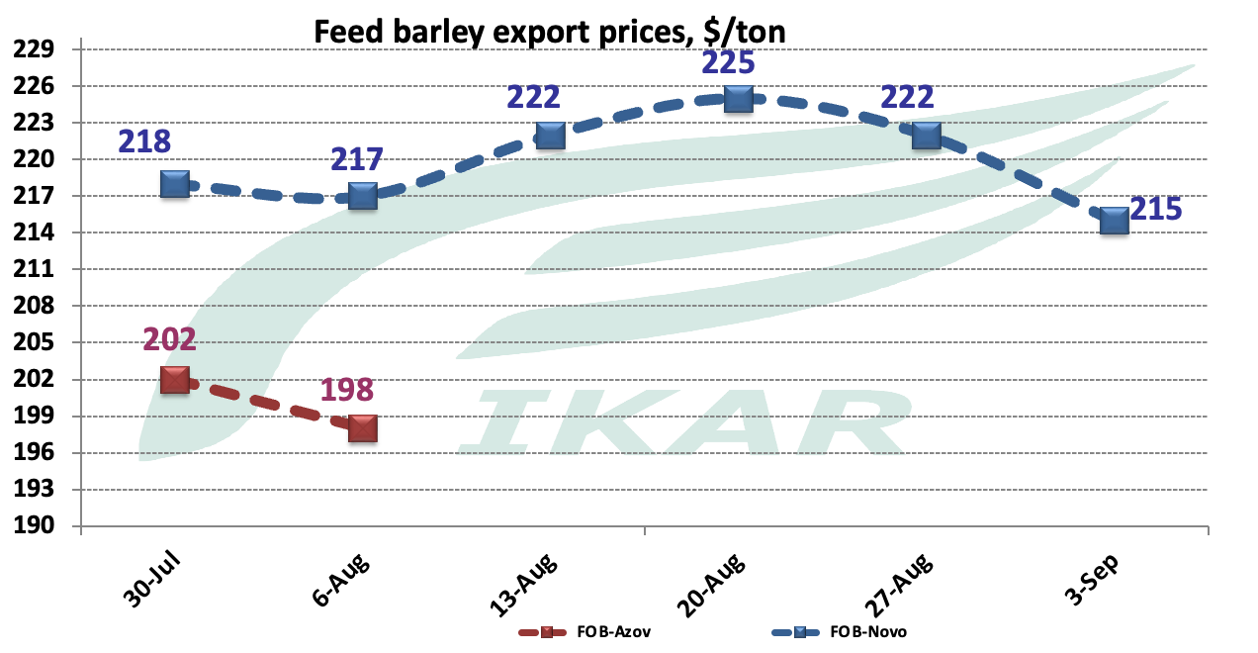

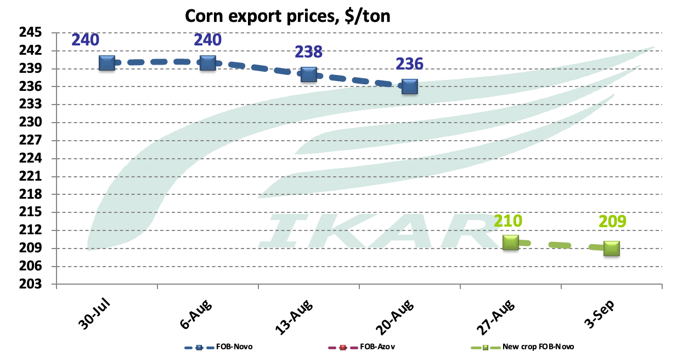

Hovever, Black Sea CPT export terminals prices look up, as, apparently, at previous levels exporters couldnotprocure enough. Preliminary, per 12.5% wheat at Black Sea terminals they pay RUR16300, at Azov Sea terminals RUR14500-14600. We will report in more details in our EOW issue.

FOB Black, Azov, Caspian Seas, and factual CPT export terminals exporters prices, VAT inclusive*
 | FOB, $/ton |  |  | CPT export terminals, RUR/ton
 | September 3 | August 26 |  | September 3 | August 26
10.5% |  |  |  | 16900 | 16900
11.5% | 226 | 230 |  | 17250 | 17250
12.5% Aug-Sep | 228 | 232 |  | 17930 | 17930
13.5% | 234 | 237 |  | 18600 | 18600
14.5% | Na | Na |  | 19300 | 19300
Feed barley | 222 | 222 |  | 17050 | 17050
Corn old crop |  |  |  | na | na
Corn new crop | 210 nominal | 210 nominal
Azov Sea |  |  |  |  |  |  |  |  |  | 13860-13970
Azov – Marmara freight rate | 42 | 40
Feed wheat |  |  |  | 14730 | 14730
10.5% | 188 nominal | 188 nominal |  | 15420 | 15420
11.5% | 192 nominal | 192 nominal |  | 15920 | 15920
12.5% | 196 nominal | 196 nominal |  | 16060 | 16060
13.5% | 201 nominal | 201 nominal |  | 16700 | 16700
14.5% | 208 nominal | 208 nominal

15.3%
Feed barley | 195 | 195 |  | na | na
Corn Jul | na | na |  | na | na
Azov – Mersin freight rates | 60 | 58
Peas, food, Azov | 240 | 244 |  | 16500-17000 nominal | 18400-18800
Peas, food, new crop Kavkaz | 272 | 272
Chick pea  below 8 mm, new crop | 440 | 441
Lentils red, new crop | 440-445 quick shipment | 480-485 quick shipment
Lentils green  Good quality large size new crop | 540-560 as a guess | 685-695 as a guess
Wheat bran | 164 nominal | 167 nominal

Caspian Sea, FOB Makhachkala/Astrakhan
Astrakhan - N.Iran ports freight rates | 38 | 37
Astrakhan barley | 203 | 208 |  | 16400-16600 | 16900-17200
Barley Aktau | 212 | 212 |  | na | na

Hot topic 5. Monthly grain railway profiles
August grain railway transportation matrix, tmt

July-August grain railway transportation matrixes, tmt

Hot topic6. Exporters rating
Five Black Sea terminals, tmt
 | 2024-25 | 2025-26
 | 5470 | 4220
GRAIN GATES | 2548 | 1853
OZK | 510 | 561
AST | 348 | 514
ASTON | 134 | 253
DEREVYANKO V.I. | 165 | 171
GRANARY | 156 | 153
DOSTAVKA MOREM | 284 | 128
RUSAGRO | 0 | 119
RESOURCE YUG TK | 107 | 104
EURASIA TRADING | 0 | 90
ZERNO ZAVOLZHIYA TD | 92 | 84
TOP GRAIN LTD | 26 | 82
ZOLOTAYA SEMECHKA | 0 | 54
TRADE OVERSEAS | 0 | 41
GRAIN SERVICE | 82 | 13
SEPTEMBER | 33
MZK | 279
DOMINANT TD | 31
AGROMARKET | 27
Алтрейд | 150
GRANOLUX | 87
PETROKHLEB | 33
AGROHOLDING STEPPE TD | 380

Pork Kavkaz
 | 2024-25 | 2025-26
 | 3034 | 1487
ASTON | 1135 | 556
GRAIN SERVICE | 382 | 201
PETROKHLEB-KUBAN | 223 | 187
TOP GRAIN LTD | 262 | 112
N/A | 0 | 97
AZT | 56 | 65
ZERNOVOY EXPORT | 0 | 59
INTROFORUS | 9 | 51
DELTRADE | 56 | 49
RESOURCE YUG TK | 54 | 26
EURASIA TRADING | 0 | 25
VIRTUM | 0 | 23
VOLGATRADE | 0 | 20
KZP EXPO | 0 | 17
AGROHOLDING STEPPE TD | 26 | 0
AZOV-DON COMPANY | 19 | 0
INKALAMU | 30 | 0
MZK EXPORT | 268 | 0
NOVOSIBIRSKKHLEBOPRODUKT | 15 | 0
ROSTOV GRAIN TERMINAL | 430 | 0
SEED & GRAIN | 5 | 0
YUG RUSI | 40 | 0
ZERNOEXPORT | 11 | 0
ZERNOVOY PUT' | 13 | 0

Azov Sea direct-to-end users coasters shipments
 | 2024-25 | 2025-26
 | 1277 | 981
N/A | 16 | 124
DELTRADE | 55 | 112
TOP GRAIN LTD | 101 | 90
GRAIN SERVICE | 33 | 88
ROSTOV GRAIN TERMINAL | 74 | 42
DEREVYANKO V.I. | 61 | 36
AGROCLUB | 32 | 31
DOSTAVKA MOREM | 16 | 30
VOLGATRADE | 14 | 30
EURASIA TRADING | 70 | 26
GRAIN FIELD | 29 | 26
NOVOSIBIRSKKHLEBOPRODUKT | 44 | 24
AGRO ZERNO YUG | 0 | 23
AGRODON | 42 | 21
INTROFORUS | 13 | 18
KZP EXPO | 34 | 16
ASTON | 0 | 16
VIRTUM | 57 | 15
ARMA | 15 | 15
AZT | 46 | 15
GRANOVITA | 0 | 14
SEED & GRAIN | 0 | 12
RUSICH-EXPORT | 20 | 11
NOVGORODPRODUCT | 3 | 11
DISTRIBUTION CENTER | 0 | 10
ZERNO ZAVOLZHIYA TD | 25 | 9
EUROTRUST | 0 | 9
ALIANCE-AGRO | 0 | 9
GRANIT | 15 | 9
RUSAGROALLIANCE APK | 12 | 8
RESOURCE YUG TK | 0 | 7
SELENA | 1 | 6
ZERNOVOY EXPORT | 0 | 6
RUSAGRO GROUP | 0 | 5
YUG RUSI | 0 | 5
GERMES AGROTRADE | 0 | 5
NB CENTER PKF | 34 | 5
SVS-AGRO | 0 | 5
AKSTAR | 0 | 4
GRAIN EXPORT | 0 | 3
ROSTSEL'EXPORT | 5 | 3
AGRO EXPORT / AZOV | 0 | 3
ENRIT | 0 | 3
SIGMAR | 0 | 3
SOFIGRAIN | 0 | 3
SUN AGRO | 25 | 3
ZEMLITSA | 0 | 3
ASVA | 0 | 3
ZERNO-TORG | 0 | 3
AGRO-ALLIANCE | 0 | 2
AGRIPPA TRADE | 10 | 0
AGROHOLDING STEPPE TD | 64 | 0
AGROINVEST / GROZNIY | 3 | 0
AGROSILA | 6 | 0
AGRO-TEMA | 7 | 0
ALEFF | 2 | 0
AZOV AGRO EXPORT | 9 | 0
BIO-TON COMPANY | 5 | 0
CONCORD AGRO | 3 | 0
DOMINANT GROUP | 6 | 0
DONBASS AGRO | 12 | 0
EKONIVA SEMENA | 6 | 0
FERMALAND | 5 | 0
FINGRAIN | 3 | 0
GEFEST AGRO | 5 | 0
GELIOS PLUS | 2 | 0
GRAIN GATES | 6 | 0
GRAIN TRADING | 5 | 0
GRAINPROM | 5 | 0
GRANARY RESOURCES | 5 | 0
GRANOLUX | 3 | 0
IDA TRADE | 4 | 0
INTERTRADE / KOMSOMOLETS | 5 | 0
KAMA AGRO + | 2 | 0

Addendum
Harvest progress as of September 2, 2025
 | Grains and pulses
Region | Area | Area harvested,Th.ha. |  | collected, TMT bunker weight |  | Yield, metric centner/ha
Region | Area | 2025 | 2024 | 2025 | 2024 | 2025 | 2024
Russian Federation | 45655 | 28 891 | 29 741 | 97 820 | 90 706 | 34 | 31
Rus Fed w/o new territories | 43796 | 27 074 | 28 048 | 94 047 | 86 761 | 35 | 31
Central Federal District | 7644 | 5 239 | 6 133 | 24 876 | 22 567 | 48 | 37
Belgorod | 584 | 468 | 490 | 2 306 | 1 797 | 49 | 37
Bryansk | 293 | 150 | 149 | 812 | 703 | 54 | 47
Vladimir | 96 | 43 | 44 | 168 | 113 | 39 | 26
Voronezh | 1480 | 1 168 | 1 050 | 4 753 | 2 883 | 41 | 27
Ivanovo | 57 | 21 | 36 | 74 | 87 | 36 | 25
Kaluga | 81 | 35 | 57 | 145 | 170 | 42 | 30
Kostroma | 23 | 7 | 13 | 21 | 26 | 29 | 19
Kursk | 765 | 583 | 700 | 3 045 | 3 226 | 52 | 46
Lipetsk | 779 | 585 | 679 | 3 052 | 2 677 | 52 | 40
Moscow Region | 171 | 74 | 121 | 307 | 396 | 41 | 33
Orel | 701 | 465 | 646 | 2 440 | 2 859 | 53 | 44
Ryazan | 713 | 452 | 629 | 2 057 | 2 361 | 46 | 38
Smolensk | 152 | 81 | 102 | 277 | 255 | 34 | 25
Tambov | 1047 | 758 | 869 | 3 739 | 2 887 | 49 | 33
Tver | 69 | 16 | 37 | 56 | 106 | 36 | 29
Tula | 593 | 331 | 494 | 1 612 | 1 974 | 49 | 40
Yaroslavl | 41 | 4 | 18 | 14 | 48 | 39 | 27
North-West Federal District | 302 | 134 | 215 | 726 | 889 | 54 | 41
Vologda | 84 | 28 | 67 | 80 | 164 | 29 | 25
Kaliningrad | 133 | 77 | 102 | 536 | 561 | 70 | 55
Leningrad Region | 40 | 16 | 21 | 59 | 71 | 38 | 33
Novgorod | 10 | 3 | 5 | 8 | 12 | 25 | 24
Pskov | 36 | 11 | 20 | 42 | 79 | 38 | 39
South Federal District | 9160 | 8 099 | 8 202 | 25 634 | 29 318 | 32 | 36
Adyghe Republic | 129 | 103 | 110 | 598 | 507 | 58 | 46
Kalmuck Republic | 283 | 271 | 271 | 838 | 729 | 31 | 27
the Crimea | 522 | 522 | 561 | 1 178 | 1 536 | 23 | 27
Krasnodar | 2483 | 2 042 | 2 014 | 9 456 | 12 162 | 46 | 60
Astrakhan | 22 | 11 | 10 | 33 | 30 | 30 | 30
Volgograd | 2174 | 1 957 | 1 923 | 5 265 | 3 404 | 27 | 18
Rostov-on-Don | 3548 | 3 193 | 3 313 | 8 265 | 10 950 | 26 | 33
North Caucasus District | 3227 | 2 717 | 2 722 | 11 436 | 9 151 | 42 | 34
Republic of Dagestan | 145 | 103 | 113 | 260 | 267 | 25 | 24
Ingush Republic | 43 | 27 | 18 | 93 | 48 | 35 | 26
Kabardian-Balkar Republic | 202 | 80 | 82 | 303 | 292 | 38 | 35
Karachaevo-Cherkessya Republic | 86 | 23 | 7 | 113 | 29 | 50 | 42
Republic of Horth Ossetia-Alania | 132 | 43 | 45 | 154 | 111 | 36 | 25
Chechen Republic | 183 | 168 | 176 | 476 | 496 | 28 | 28
Stavropol | 2435 | 2 275 | 2 280 | 10 037 | 7 908 | 44 | 35
Volga Federal District | 12296 | 8 235 | 8 129 | 24 560 | 18 874 | 30 | 23
Bashkir Republic | 1379 | 613 | 487 | 1 911 | 1 151 | 31 | 24
Mari El Republic | 140 | 62 | 98 | 199 | 235 | 32 | 24
Republic of Mordovia | 487 | 400 | 386 | 1 553 | 1 105 | 39 | 29
Republic of Tatarstan | 1286 | 911 | 793 | 3 628 | 2 349 | 40 | 30
Udmurt Republic | 323 | 127 | 130 | 408 | 327 | 32 | 25
Chuvash Republic | 281 | 166 | 196 | 638 | 569 | 38 | 29
Perm | 176 | 39 | 42 | 99 | 91 | 26 | 22
Kirov | 304 | 88 | 123 | 274 | 292 | 31 | 24
Nizhny Novgorod | 618 | 357 | 479 | 1 237 | 1 248 | 35 | 26
Orenburg | 2389 | 1 545 | 1 055 | 3 088 | 2 094 | 20 | 20
Penza | 847 | 669 | 800 | 2 732 | 2 421 | 41 | 30
Samara | 1195 | 898 | 926 | 2 654 | 2 024 | 30 | 22
Saratov | 2247 | 1 828 | 2 025 | 4 190 | 3 362 | 23 | 17
Ulianovsk | 624 | 532 | 589 | 1 949 | 1 608 | 37 | 27
Ural Federal District | 2960 | 626 | 321 | 1 574 | 693 | 25 | 22
Kurgan | 840 | 139 | 110 | 353 | 237 | 25 | 21
Sverdlovsk | 313 | 54 | 34 | 161 | 94 | 30 | 28
Tyumen | 633 | 158 | 96 | 486 | 237 | 31 | 25
Chelyabinsk | 1175 | 276 | 81 | 573 | 126 | 21 | 16
Siberian Federal District | 7707 | 1 873 | 2 165 | 4 878 | 4 862 | 26 | 23
Khakass Republic | 78 | 5 | 16 | 14 | 28 | 25 | 17
Altai | 2753 | 862 | 898 | 2 083 | 1 965 | 24 | 22
Krasnoyarsk | 786 | 195 | 332 | 654 | 932 | 34 | 28
Irkutsk | 323 | 44 | 76 | 107 | 175 | 24 | 23
Kemerovo | 531 | 172 | 196 | 543 | 488 | 32 | 25
Novosibirsk | 1200 | 269 | 237 | 822 | 542 | 31 | 23
Omsk | 1877 | 273 | 371 | 501 | 635 | 18 | 17
Tomsk | 145 | 54 | 38 | 156 | 97 | 29 | 25
Far Eastern Federal District | 500 | 151 | 162 | 363 | 408 | 24 | 25
Primorye Territory | 147 | 15 | 15 | 29 | 22 | 20 | 15
Khabarovsk Territory | 7 | 4 | 3 | 6 | 7 | 16 | 22
Amur Region | 174 | 130 | 136 | 326 | 365 | 25 | 27
Jewish Autonomous Region | 11 | 2 | 3 | 3 | 5 | 16 | 17
Total for new subjects | 1859 | 1 817 | 1 693 | 3 773 | 3 946 | 21 | 23
Donetsk | 245 | 236 | 221 | 417 | 481 | 18 | 22
Luhansk | 334 | 334 | 281 | 855 | 518 | 26 | 18
Zaporozhye | 667 | 615 | 617 | 1 261 | 1 640 | 21 | 27
Kherson | 613 | 633 | 574 | 1 240 | 1 306 | 20 | 23

 | WHEAT
Region | Area | Area harvested,Th.ha. |  | collected, TMT bunker weight |  | Yield, metric centner/ha
Region | Area | 2025 | 2024 | 2025 | 2024 | 2025 | 2024
Russian Federation | 28308 | 19707 | 20558 | 72555 | 69262 | 37 | 34
Rus Fed w/o new territories | 26904 | 18337 | 19256 | 69526 | 65983 | 38 | 34
Central Federal District | 4586 | 3717 | 4288 | 18560 | 16743 | 50 | 39
Belgorod | 408 | 394 | 391 | 2026 | 1489 | 51 | 38
Bryansk | 125 | 109 | 108 | 620 | 519 | 57 | 48
Vladimir | 53 | 27 | 27 | 114 | 75 | 42 | 28
Voronezh | 845 | 808 | 669 | 3430 | 1920 | 43 | 29
Ivanovo | 25 | 13 | 17 | 49 | 43 | 39 | 25
Kaluga | 47 | 27 | 38 | 121 | 125 | 45 | 33
Kostroma | ... | 3 | 3 | 9 | 7 | 31 | 25
Kursk | 464 | 434 | 524 | 2336 | 2487 | 54 | 48
Lipetsk | 527 | 428 | 496 | 2335 | 2014 | 55 | 41
Moscow Region | 114 | 56 | 91 | 251 | 316 | 45 | 35
Orel | 434 | 334 | 463 | 1844 | 2205 | 55 | 48
Ryazan | 442 | 285 | 412 | 1413 | 1691 | 50 | 41
Smolensk | 67 | 46 | 58 | 173 | 160 | 38 | 28
Tambov | 591 | 502 | 602 | 2565 | 2096 | 51 | 35
Tver | 45 | 12 | 27 | 49 | 85 | 42 | 32
Tula | 379 | 239 | 359 | 1219 | 1495 | 51 | 42
Yaroslavl | 13 | 2 | 5 | 8 | 16 | 41 | 30
North-West Federal District | 151 | 79 | 119 | 497 | 593 | 63 | 50
Vologda | 16 | 3 | 11 | 14 | 27 | 41 | 25
Kaliningrad | 89 | 58 | 79 | 418 | 455 | 72 | 58
Leningrad Region | 14 | 5 | 9 | 21 | 32 | 39 | 35
Novgorod | 5 | 2 | 3 | 5 | 9 | 26 | 36
Pskov | 27 | 10 | 17 | 39 | 70 | 40 | 40
South Federal District | 6693 | 6528 | 6597 | 22134 | 25366 | 34 | 39
Adyghe Republic | 91 | 88 | 91 | 542 | 454 | 61 | 50
Kalmuck Republic | 240 | 235 | 241 | 761 | 667 | 32 | 28
the Crimea | 306 | 306 | 317 | 784 | 977 | 26 | 31
Krasnodar | 1632 | 1632 | 1589 | 7865 | 10283 | 48 | 65
Astrakhan | ... | 4 | 5 | 14 | 16 | 33 | 34
Volgograd | 1586 | 1572 | 1542 | 4666 | 2963 | 30 | 19
Rostov-on-Don | 2832 | 2691 | 2813 | 7502 | 10004 | 28 | 36
North Caucasus District | 2043 | 2037 | 2033 | 9184 | 7278 | 45 | 36
Republic of Dagestan | 61 | 61 | 74 | 164 | 178 | 27 | 24
Ingush Republic | 17 | 17 | 11 | 64 | 34 | 38 | 30
Kabardian-Balkar Republic | 56 | 55 | 56 | 202 | 210 | 37 | 37
Karachaevo-Cherkessya Republic | 20 | 17 | 5 | 93 | 24 | 57 | 47
Republic of Horth Ossetia-Alania | 33 | 32 | 33 | 124 | 99 | 38 | 30
Chechen Republic | 93 | 93 | 106 | 322 | 316 | 35 | 30
Stavropol | 1762 | 1762 | 1748 | 8216 | 6419 | 47 | 37
Volga Federal District | 7143 | 5070 | 5232 | 16612 | 13415 | 33 | 26
Bashkir Republic | 762 | 289 | 265 | 1011 | 697 | 35 | 26
Mari El Republic | 56 | 19 | 38 | 71 | 104 | 38 | 28
Republic of Mordovia | 257 | 221 | 214 | 896 | 688 | 41 | 32
Republic of Tatarstan | 774 | 541 | 468 | 2285 | 1475 | 42 | 32
Udmurt Republic | 115 | 29 | 39 | 116 | 108 | 40 | 28
Chuvash Republic | 151 | 90 | 116 | 366 | 359 | 41 | 31
Perm | 77 | 8 | 11 | 21 | 23 | 25 | 21
Kirov | 89 | 14 | 27 | 50 | 67 | 37 | 25
Nizhny Novgorod | 372 | 233 | 298 | 864 | 846 | 37 | 28
Orenburg | 1586 | 1012 | 739 | 2367 | 1668 | 23 | 23
Penza | 611 | 501 | 622 | 2101 | 1969 | 42 | 32
Samara | 671 | 580 | 612 | 1966 | 1570 | 34 | 26
Saratov | 1223 | 1182 | 1392 | 3156 | 2669 | 27 | 19
Ulianovsk | 401 | 350 | 395 | 1343 | 1173 | 38 | 30
Ural Federal District | 1847 | 245 | 74 | 594 | 149 | 24 | 20
Kurgan | 574 | 58 | 29 | 135 | 56 | 23 | 20
Sverdlovsk | 145 | 13 | 5 | 42 | 13 | 34 | 26
Tyumen | 391 | 39 | 7 | 122 | 19 | 31 | 25
Chelyabinsk | 738 | 135 | 33 | 295 | 62 | 22 | 19
Siberian Federal District | 4303 | 596 | 829 | 1766 | 2220 | 30 | 27
Khakass Republic | 39 | 2 | 10 | 8 | 19 | 34 | 20
Altai | 1434 | 327 | 370 | 970 | 1010 | 30 | 27
Krasnoyarsk | 441 | 62 | 168 | 206 | 478 | 33 | 28
Irkutsk | 161 | 2 | 19 | 2 | 37 | 15 | 19
Kemerovo | 252 | 37 | 59 | 123 | 166 | 33 | 28
Novosibirsk | 677 | 73 | 71 | 246 | 210 | 34 | 30
Omsk | 1213 | 75 | 116 | 150 | 256 | 20 | 22
Tomsk | 84 | 18 | 16 | 60 | 43 | 33 | 28
Far Eastern Federal District | 139 | 66 | 84 | 179 | 219 | 27 | 26
Primorye Territory | 4 | 3 | 4 | 6 | 5 | 18 | 13
Khabarovsk Territory | 1 | 1 | 1 | 1 | 2 | 19 | 26
Amur Region | 66 | 62 | 78 | 171 | 210 | 28 | 27
Jewish Autonomous Region | 2 | 1 | 1 | 1 | 1 | 13 | 16
Total for new subjects | 1405 | 1370 | 1302 | 3029 | 3279 | 22 | 25
Donetsk | 183 | 184 | 172 | 358 | 411 | 19 | 24
Luhansk | 270 | 286 | 238 | 771 | 469 | 27 | 20
Zaporozhye | 506 | 463 | 479 | 982 | 1383 | 21 | 29
Kherson | 446 | 436 | 413 | 918 | 1016 | 21 | 25

 | BARLEY
Region | Area | Area harvested,Th.ha. |  | collected, TMT bunker weight |  | Yield, metric centner/ha
Region | Area | 2025 | 2024 | 2025 | 2024 | 2025 | 2024
Russian Federation | 6957 | 4701 | 4701 | 15267 | 13148 | 33 | 28
Rus Fed w/o new territories | 6653 | 4393 | 4404 | 14689 | 12584 | 33 | 29
Central Federal District | 1255 | 1004 | 1204 | 4535 | 4166 | 45 | 35
Belgorod | 59 | 54 | 60 | 219 | 186 | 41 | 31
Bryansk | 20 | 19 | 17 | 86 | 65 | 44 | 40
Vladimir | 20 | 6 | 5 | 24 | 14 | 38 | 29
Voronezh | 285 | 273 | 301 | 1044 | 808 | 38 | 27
Ivanovo | 16 | 5 | 9 | 18 | 28 | 35 | 30
Kostroma | ... | 2 | 3 | 6 | 9 | 31 | 25
Kursk | 128 | 122 | 147 | 627 | 670 | 52 | 46
Lipetsk | 136 | 123 | 142 | 610 | 540 | 50 | 38
Moscow Region | 26 | 5 | 14 | 17 | 39 | 33 | 29
Orel | 125 | 96 | 123 | 472 | 493 | 49 | 40
Ryazan | 109 | 70 | 84 | 319 | 304 | 46 | 36
Smolensk | 21 | 1 | 14 | 3 | 36 | 33 | 27
Tambov | 184 | 173 | 193 | 818 | 619 | 47 | 32
Tula | 95 | 54 | 78 | 259 | 313 | 48 | 40
Yaroslavl | 16 | 1 | 9 | 5 | 26 | 41 | 28
North-West Federal District | 98 | 45 | 74 | 198 | 230 | 44 | 31
Vologda | 54 | 21 | 47 | 59 | 110 | 29 | 24
Kaliningrad | 16 | 15 | 16 | 103 | 82 | 68 | 51
Leningrad Region | 23 | 9 | 10 | 34 | 34 | 39 | 33
South Federal District | 752 | 734 | 807 | 2131 | 2507 | 29 | 31
Adyghe Republic | 9 | 8 | 8 | 43 | 41 | 52 | 49
Kalmuck Republic | 18 | 18 | 15 | 45 | 32 | 26 | 22
the Crimea | 157 | 156 | 189 | 358 | 499 | 23 | 26
Krasnodar | 181 | 180 | 174 | 1001 | 1222 | 56 | 70
Astrakhan | 6 | 6 | 5 | 18 | 14 | 31 | 26
Volgograd | 147 | 143 | 172 | 250 | 170 | 17 | 10
Rostov-on-Don | 236 | 222 | 243 | 416 | 529 | 19 | 22
North Caucasus District | 340 | 316 | 313 | 1302 | 1098 | 41 | 35
Republic of Dagestan | 43 | 37 | 39 | 96 | 88 | 26 | 23
Ingush Republic | 6 | 6 | 7 | 29 | 16 | 46 | 23
Kabardian-Balkar Republic | 22 | 22 | 15 | 84 | 57 | 39 | 38
Karachaevo-Cherkessya Republic | 4 | 4 | 1 | 19 | 6 | 48 | 40
Republic of Horth Ossetia-Alania | 7 | 7 | 4 | 26 | 11 | 37 | 29
Chechen Republic | 47 | 38 | 42 | 103 | 113 | 27 | 27
Stavropol | 212 | 202 | 205 | 945 | 808 | 47 | 39
Volga Federal District | 2363 | 1692 | 1449 | 4823 | 3175 | 29 | 22
Bashkir Republic | 339 | 189 | 116 | 576 | 259 | 31 | 22
Mari El Republic | 38 | 17 | 24 | 60 | 62 | 35 | 26
Republic of Mordovia | 112 | 94 | 100 | 369 | 272 | 39 | 27
Republic of Tatarstan | 319 | 268 | 201 | 1016 | 599 | 38 | 30
Udmurt Republic | 126 | 61 | 52 | 199 | 136 | 32 | 26
Chuvash Republic | 90 | 52 | 51 | 193 | 145 | 37 | 28
Perm | 58 | 18 | 17 | 50 | 38 | 28 | 23
Kirov | 113 | 31 | 34 | 114 | 82 | 37 | 24
Nizhny Novgorod | 117 | 49 | 88 | 163 | 219 | 33 | 25
Orenburg | 407 | 320 | 163 | 407 | 192 | 13 | 12
Penza | 112 | 104 | 110 | 441 | 329 | 42 | 30
Samara | 204 | 178 | 178 | 416 | 280 | 23 | 16
Saratov | 205 | 198 | 198 | 411 | 268 | 21 | 14
Ulianovsk | 122 | 113 | 117 | 409 | 294 | 36 | 25
Ural Federal District | 602 | 144 | 77 | 355 | 176 | 25 | 23
Kurgan | 115 | 13 | 12 | 33 | 28 | 25 | 22
Sverdlovsk | 122 | 29 | 20 | 88 | 60 | 31 | 31
Tyumen | 92 | 27 | 20 | 90 | 56 | 34 | 28
Chelyabinsk | 274 | 75 | 25 | 143 | 33 | 19 | 13
Siberian Federal District | 1169 | 403 | 427 | 1224 | 1090 | 30 | 26
Khakass Republic | 7 | 1 | 2 | 2 | 4 | 28 | 20
Altai | 238 | 114 | 107 | 308 | 251 | 27 | 23
Krasnoyarsk | 147 | 66 | 92 | 246 | 279 | 37 | 30
Irkutsk | 72 | 24 | 40 | 61 | 100 | 26 | 25
Kemerovo | 116 | 66 | 57 | 229 | 153 | 35 | 27
Novosibirsk | 223 | 71 | 50 | 241 | 126 | 34 | 25
Omsk | 346 | 47 | 70 | 95 | 155 | 20 | 22
Tomsk | 21 | 14 | 9 | 42 | 22 | 29 | 24
Far Eastern Federal District | 73 | 55 | 52 | 121 | 141 | 22 | 27
Primorye Territory | 3 | 3 | 3 | 6 | 5 | 21 | 17
Khabarovsk Territory | 1 | 1 | 1 | 1 | 1 | 13 | 14
Amur Region | 52 | 52 | 47 | 114 | 132 | 22 | 28
Jewish Autonomous Region | 1 | 1 | 1 | 1 | 1 | 17 | 16
Total for new subjects | 304 | 308 | 297 | 578 | 564 | 19 | 19
Donetsk | 36 | 34 | 39 | 47 | 61 | 14 | 16
Luhansk | 35 | 33 | 34 | 68 | 42 | 20 | 12
Zaporozhye | 77 | 81 | 85 | 172 | 199 | 21 | 23
Kherson | 156 | 160 | 140 | 292 | 262 | 18 | 19

 | Rye
Region | Area | Area harvested,Th.ha. |  | collected, TMT bunker weight |  | Yield, metric centner/ha
Region | Area | 2025 | 2024 | 2025 | 2024 | 2025 | 2024
Russian Federation | 452,1 | 369 | 470 | 960 | 996 | 26 | 21
Rus Fed w/o new territories | 450,90 | 368 | 470 | 957 | 996 | 26 | 21
Central Federal District | 70,8 | 42 | 51 | 163 | 156 | 39 | 31
Bryansk | 14,5 | 13 | 15 | 43 | 57 | 34 | 38
Vladimir | 2,5 | 1 | 1 | 4 | 2 | 29 | 18
Voronezh | 10,7 | 11 | 10 | 37 | 24 | 35 | 23
Ivanovo | 2,4 | 1 | 2 | 5 | 4 | 39 | 19
Kostroma | 2,4 | 1 | 1 | 4 | 4 | 32 | 25
Lipetsk | 2,7 | 3 | 2 | 13 | 10 | 50 | 47
Moscow Region | 2,4 | 1 | 2 | 4 | 6 | 50 | 39
Orel | 1,7 | 1 | 0 | 7 | 0 | 53
Ryazan | 12,6 | 8 | 9 | 30 | 26 | 36 | 29
Tambov | 1,2 | 1 | 3 | 4 | 10 | 35 | 30
Tver | 1,6 | 1 | 3 | 1 | 6 | 19 | 20
North-West Federal District | 5,8 | 2 | 1 | 13 | 3 | 57 | 23
Vologda | 1,3 | 1 | 1 | 1 | 3 | 23 | 22
Kaliningrad | 4,2 | 2 | 0 | 12 | 0 | 65
South Federal District | 33,4 | 28 | 27 | 50 | 39 | 18 | 14
the Crimea | 2,4 | 2 | 3 | 5 | 5 | 21 | 17
Astrakhan | 0,8 | 1 | 0 | 1 | 0 | 24
Volgograd | 27,7 | 25 | 24 | 43 | 34 | 17 | 14
Rostov-on-Don | 1,1 | 1 | 0 | 1 | 0 | 27
Volga Federal District | 286,8 | 255 | 359 | 608 | 721 | 24 | 20
Bashkir Republic | 43,5 | 41 | 53 | 109 | 101 | 26 | 19
Mari El Republic | 15,2 | 13 | 16 | 31 | 35 | 24 | 21
Republic of Mordovia | 4,5 | 4 | 4 | 8 | 8 | 22 | 22
Republic of Tatarstan | 35,4 | 31 | 47 | 106 | 118 | 34 | 25
Udmurt Republic | 24,2 | 19 | 22 | 45 | 43 | 24 | 20
Chuvash Republic | 4,1 | 4 | 6 | 10 | 16 | 29 | 26
Perm | 6,0 | 6 | 6 | 12 | 12 | 22 | 19
Kirov | 45,5 | 35 | 45 | 84 | 107 | 24 | 24
Nizhny Novgorod | 10,6 | 9 | 12 | 26 | 24 | 30 | 21
Orenburg | 61,8 | 62 | 92 | 106 | 160 | 17 | 17
Penza | 2,1 | 2 | 3 | 4 | 6 | 24 | 20
Samara | 5,7 | 5 | 10 | 11 | 19 | 24 | 19
Saratov | 23,4 | 23 | 38 | 45 | 60 | 20 | 16
Ulianovsk | 4,8 | 4 | 6 | 11 | 13 | 29 | 23
Ural Federal District | 11,3 | 10 | 3 | 42 | 7 | 42 | 26
Kurgan | ... | 9 | 0 | 39 | 0 | 42
Sverdlovsk | 1,2 | 1 | 2 | 3 | 5 | 34 | 29
Siberian Federal District | 42,1 | 30 | 28 | 81 | 68 | 27 | 24
Altai | 12,2 | 11 | 0 | 33 | 0 | 30
Kemerovo | 5,3 | 5 | 6 | 16 | 15 | 33 | 25
Novosibirsk | 7,6 | 6 | 8 | 18 | 19 | 28 | 23
Tomsk | 7,1 | 7 | 5 | 12 | 12 | 18 | 23
Total for new subjects | 1,2 | 2 | 1 | 3 | 1 | 18 | 14
Luhansk | 0,8 | 1 | 0 | 2 | 1 | 23 | 15
Kherson | 0,2 | 1 | 0 | 1 | 0 | 14

 | Peas
Region | Area | Area harvested,Th.ha. |  | collected, TMT bunker weight |  | Yield, metric centner/ha
Region | Area | 2025 | 2024 | 2025 | 2024 | 2025 | 2024
Russian Federation | 2231 | 1616 | 1289 | 4882 | 2566 | 30 | 20
Rus Fed w/o new territories | 2159 | 1529 | 1258 | 4767 | 2531 | 31 | 20
Central Federal District | 379 | 300 | 310 | 1062 | 758 | 36 | 24
Belgorod | 5 | 5 | 14 | 15 | 26 | 30 | 19
Bryansk | 2 | 1 | 2 | 4 | 5 | 30 | 25
Voronezh | 40 | 40 | 35 | 130 | 60 | 32 | 17
Kursk | 15 | 15 | 14 | 49 | 33 | 32 | 23
Lipetsk | 31 | 31 | 30 | 110 | 83 | 36 | 28
Moscow Region | 12 | 10 | 13 | 32 | 31 | 30 | 24
Orel | 33 | 26 | 30 | 79 | 84 | 31 | 28
Ryazan | 83 | 65 | 71 | 227 | 187 | 35 | 26
Tambov | 81 | 77 | 62 | 322 | 137 | 42 | 22
Tula | 50 | 29 | 39 | 94 | 113 | 32 | 29
North-West Federal District | 5 | 1 | 1 | 1 | 2 | 21 | 30
Pskov | 3 | 1 | 1 | 1 | 2 | 21 | 30
South Federal District | 377 | 376 | 171 | 678 | 402 | 18 | 24
Adyghe Republic | 2 | 1 | 2 | 7 | 6 | 48 | 24
Kalmuck Republic | 11 | 11 | 9 | 23 | 26 | 21 | 28
the Crimea | 17 | 17 | 25 | 14 | 35 | 8 | 14
Krasnodar | 155 | 155 | 128 | 376 | 328 | 24 | 26
Volgograd | 5 | 4 | 7 | 8 | 7 | 19 | 10
Rostov-on-Don | 188 | 187 | 0 | 251 | 0 | 13
North Caucasus District | 243 | 241 | 4 | 777 | 7 | 32 | 18
Kabardian-Balkar Republic | 3 | 3 | 0 | 3 | 0 | 12
Chechen Republic | 3 | 3 | 3 | 6 | 6 | 22 | 18
Stavropol | 236 | 235 | 0 | 767 | 0 | 33
Volga Federal District | 457 | 156 | 359 | 1132 | 641 | 73 | 18
Bashkir Republic | 41 | 36 | 21 | 82 | 35 | 22 | 17
Mari El Republic | 12 | 7 | 10 | 20 | 15 | 27 | 15
Republic of Mordovia | 69 | 69 | 60 | 230 | 124 | 34 | 20
Ulianovsk | 46 | 43 | 45 | 134 | 76 | 31 | 17
Ural Federal District | 167 | 115 | 100 | 294 | 192 | 26 | 19
Kurgan | 57 | 41 | 40 | 108 | 73 | 26 | 18
Tyumen | 68 | 57 | 48 | 154 | 103 | 27 | 21
Chelyabinsk | 27 | 16 | 9 | 32 | 8 | 20 | 9
Siberian Federal District | 530 | 343 | 313 | 822 | 528 | 24 | 17
Altai | 146 | 126 | 0 | 301 | 0 | 24
Irkutsk | 24 | 15 | 11 | 37 | 25 | 25 | 23
Kemerovo | 68 | 44 | 60 | 120 | 120 | 27 | 20
Novosibirsk | 116 | 78 | 88 | 205 | 139 | 26 | 16
Omsk | 117 | 74 | 113 | 139 | 150 | 19 | 13
Tomsk | 8 | 6 | 6 | 17 | 14 | 27 | 24
Total for new subjects | 72 | 87 | 31 | 115 | 36 | 13 | 12
Donetsk | 8 | 9 | 9 | 11 | 9 | 12 | 10
Luhansk | 2 | 4 | 3 | 4 | 3 | 11 | 9
Zaporozhye | 54 | 45 | 0 | 76 | 0 | 17
Kherson | 7 | 29 | 19 | 24 | 24 | 8 | 13

 | CORN
Region | Area | Area harvested,Th.ha. |  | collected, TMT bunker weight |  | Yield, metric centner/ha
Region | Area | 2024 | 2023 | 2024 | 2023 | 2024 | 2023
Russian Federation | 2 642 | 49,80 | 129,40 | 172,50 | 374 | 34,6 | 28,9
Rus Fed w/o new territories | 2 588 | 50,0 | 129,0 | 173,0 | 374,0 | 35,0 | 29,0
South Federal District | 588 | 48 | 108 | 164 | 282 | 33,9 | 26,0
Adyghe Republic | 15 | 1 | 0 | 2 | 2 | 35,6 | 48,6
Krasnodar | 369 | 47 | 107 | 161 | 278 | 34,2 | 26,0
Rostov-on-Don | 107 | 1 | 1 | 1 | 2 | 9,2 | 16,7
North Caucasus District | 455 | 2 | 16 | 9 | 52 | 56,7 | 33,0
Stavropol | 134 | 1 | 11 | 6 | 36 | 46,7 | 31,4

 | RAPE
Region | Area | Area harvested,Th.ha. |  | collected, TMT bunker weight |  | Yield, metric centner/ha
Region | Area | 2025 | 2024 | 2025 | 2024 | 2025 | 2024
Russian Federation | 3041 | 776 | 941 | 1846 | 2217 | 24 | 24
Rus Fed w/o new territories | 2960 | 696 | 859 | 1757 | 2133 | 25 | 25
Central Federal District | 651 | 311 | 486 | 882 | 1314 | 28 | 27
Bryansk | 94 | 70 | 78 | 209 | 301 | 30 | 39
Vladimir | 5 | 1 | 0 | 4 | 1 | 33 | 32
Ivanovo | 7 | 4 | 2 | 9 | 3 | 24 | 13
Kaluga | 19 | 11 | 11 | 29 | 23 | 28 | 21
Kursk | 41 | 32 | 64 | 80 | 196 | 25 | 31
Lipetsk | 60 | 28 | 52 | 81 | 102 | 29 | 20
Moscow Region | 49 | 13 | 13 | 32 | 37 | 25 | 28
Orel | 129 | 72 | 117 | 225 | 316 | 31 | 27
Ryazan | 76 | 24 | 48 | 67 | 107 | 28 | 22
Smolensk | 32 | 20 | 11 | 34 | 19 | 18 | 17
Tambov | 14 | 8 | 13 | 24 | 23 | 31 | 17
Tver | 10 | 2 | 2 | 5 | 4 | 22 | 18
Tula | 108 | 28 | 71 | 81 | 174 | 29 | 25
Yaroslavl | 5 | 1 | 2 | 2 | 4 | 34 | 27
North-West Federal District | 87 | 59 | 58 | 186 | 182 | 32 | 31
Kaliningrad | 60 | 53 | 52 | 173 | 173 | 32 | 33
Leningrad Region | ... | 2 | 3 | 6 | 5 | 26 | 19
Pskov | 15 | 3 | 3 | 7 | 3 | 23 | 11
South Federal District | 102 | 94 | 108 | 217 | 264 | 23 | 25
Adyghe Republic | 11 | 11 | 9 | 29 | 18 | 28 | 20
the Crimea | 12 | 12 | 3 | 15 | 4 | 13 | 15
Krasnodar | 68 | 67 | 71 | 167 | 194 | 25 | 27
Rostov-on-Don | 10 | 5 | 25 | 6 | 48 | 12 | 19
North Caucasus District | 120 | 99 | 90 | 168 | 175 | 17 | 19
Ingush Republic | 1 | 1 | 1 | 1 | 1 | 12 | 13
Kabardian-Balkar Republic | 6 | 6 | 5 | 12 | 16 | 22 | 29
Republic of Horth Ossetia-Alania | 12 | 11 | 19 | 21 | 36 | 18 | 19
Chechen Republic | 36 | 28 | 21 | 43 | 27 | 15 | 13
Stavropol | 65 | 53 | 44 | 91 | 96 | 17 | 22
Volga Federal District | 360 | 102 | 52 | 243 | 90 | 24 | 17
Bashkir Republic | 81 | 13 | 2 | 28 | 3 | 22 | 21
Mari El Republic | 4 | 1 | 0 | 2 | 0 | 25
Republic of Mordovia | 15 | 6 | 11 | 12 | 15 | 21 | 13
Republic of Tatarstan | 159 | 45 | 19 | 113 | 41 | 25 | 22
Udmurt Republic | 9 | 3 | 1 | 4 | 1 | 15 | 10
Chuvash Republic | 16 | 3 | 1 | 6 | 3 | 20 | 17
Kirov | 8 | 1 | 0 | 1 | 0 | 19 | 8
Nizhny Novgorod | 22 | 9 | 5 | 24 | 9 | 26 | 17
Penza | 13 | 9 | 10 | 25 | 14 | 29 | 14
Ulianovsk | 16 | 13 | 2 | 29 | 3 | 22 | 18
Ural Federal District | 152 | 2 | 0 | 5 | 0 | 29 | 24
Chelyabinsk | 20 | 2 | 0 | 5 | 0 | 28
Siberian Federal District | 1445 | 30 | 65 | 56 | 107 | 19 | 17
Altai | 296 | 25 | 47 | 48 | 76 | 20 | 16
Kemerovo | 201 | 1 | 1 | 2 | 2 | 14 | 17
Novosibirsk | 253 | 3 | 5 | 5 | 9 | 16 | 17
Omsk | 235 | 1 | 1 | 1 | 3 | 21 | 40
Total for new subjects | 81 | 80 | 82 | 90 | 84 | 11 | 10
Zaporozhye | 25 | 25 | 28 | 28 | 35 | 11 | 12
Kherson | 56 | 54 | 53 | 61 | 49 | 11 | 9

 |  | SUNFLOWER
Region | Area | Area harvested,Th.ha. |  | collected, TMT bunker weight |  | Yield, metric centner/ha
Region | Area | 2025 | 2024 | 2025 | 2024 | 2025 | 2024
Russian Federation | 12218 | 600 | 477 | 549 | 812 | 9 | 17
Rus Fed w/o new territories | 11040 | 386 | 393 | 469 | 716 | 12 | 18
Central Federal District | 1616 | 8 | 13 | 16 | 36 | 20 | 29
Voronezh | 549 | 7 | 0 | 13 | 0 | 19
Lipetsk | 190 | 1 | 5 | 2 | 17 | 26 | 37
South Federal District | 2478 | 311 | 300 | 345 | 545 | 11 | 18
Adyghe Republic | 58 | 13 | 14 | 24 | 23 | 19 | 17
the Crimea | 38 | 6 | 4 | 5 | 4 | 8 | 10
Krasnodar | 498 | 211 | 187 | 258 | 375 | 12 | 20
Rostov-on-Don | 1022 | 81 | 96 | 58 | 143 | 7 | 15
North Caucasus District | 335 | 63 | 80 | 102 | 136 | 16 | 17
Stavropol | 265 | 63 | 80 | 102 | 136 | 16 | 17
Volga Federal District | 5139 | 4 | 0 | 6 | 0 | 14
Samara | 786 | 2 | 0 | 3 | 0 | 15
Saratov | 1604 | 2 | 0 | 3 | 0 | 14
Total for new subjects | 1178 | 214 | 84 | 80 | 96 | 4 | 12
Donetsk | 138 | 2 | 4 | 1 | 6 | 5 | 14
Luhansk | 297 | 5 | 10 | 7 | 17 | 14 | 16
Kherson | 308 | 207 | 54 | 72 | 54 | 4 | 10

